In response to:



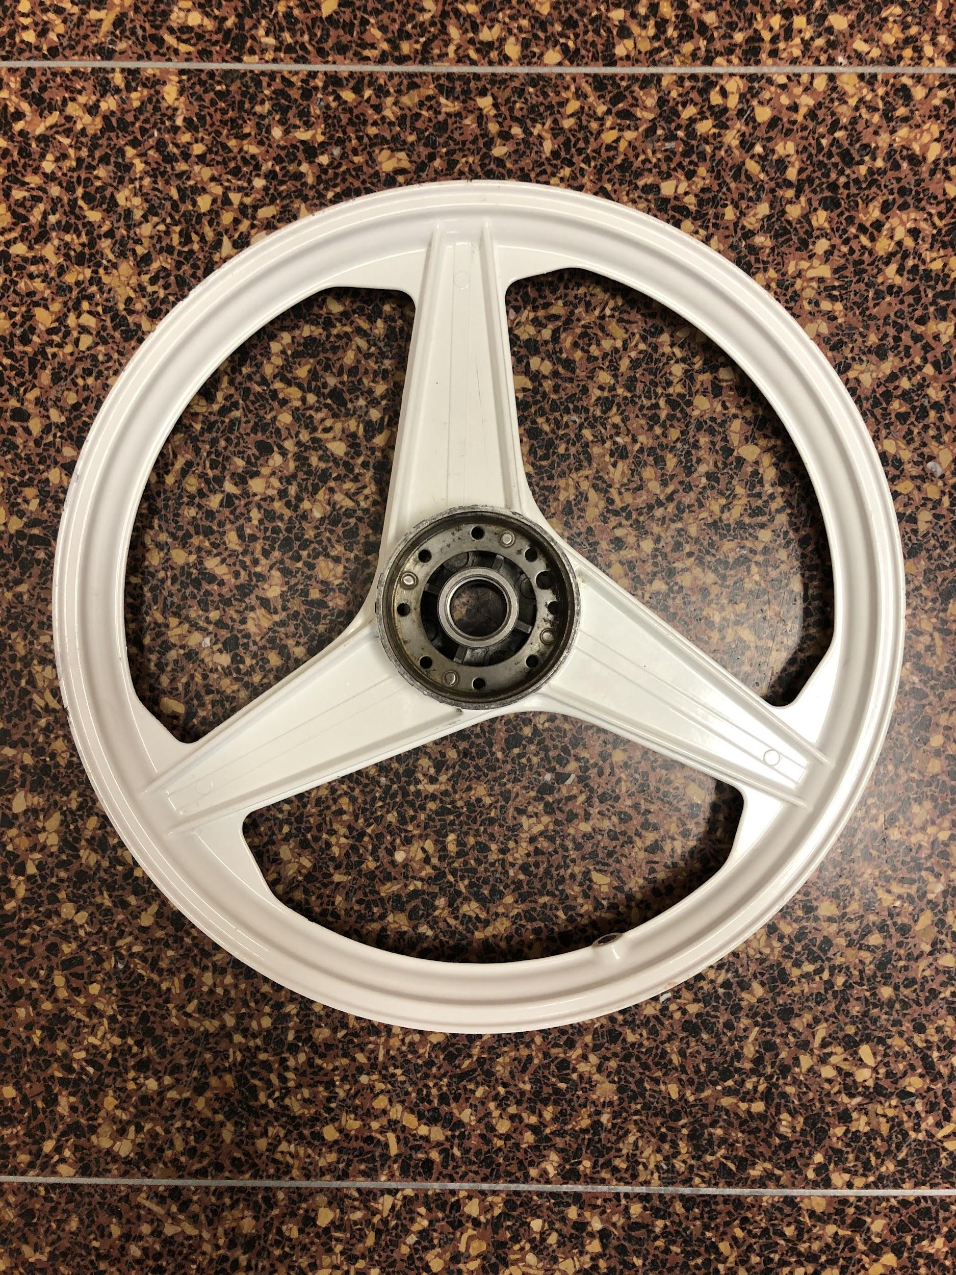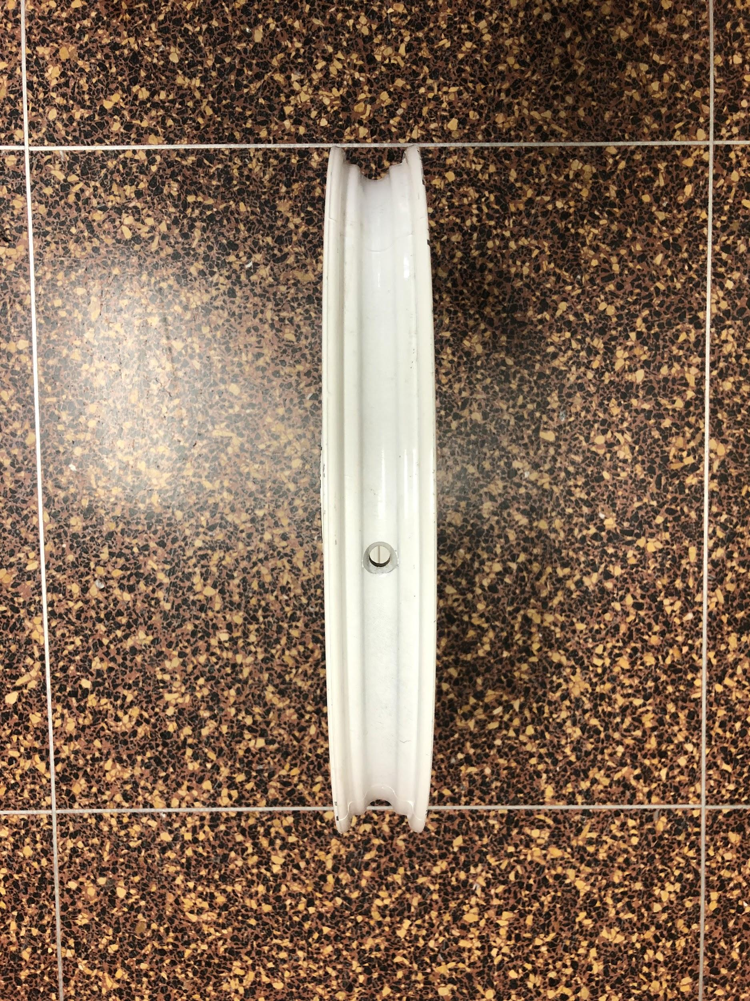

The process of finding documentation for the specific wheels started by researching the type of wheel we actually purchased. After looking up the name of the company stamped on the wheel “Bernardi Mozzi”, we stumbled across many online resources like Myron’s Mopeds and Moped Army which show images of various mopeds with these exact wheels. After we discovered that these wheels were used on old-style mopeds, we learned that these types of mag alloy moped wheels are very popular in the high-efficiency racing sports like Electrathon USA, which features vehicles similar to the size and weight of a typical solar car. Many other colleges and high schools also use these wheels in their high-efficiency vehicle projects as well. A website that specializes in parts for Electrathon racing is shiftev.com -- in fact, they carry very similar wheels of these specs:

* Wheel accepts both DOT tires size 16"x2.5" (not included), AND high-pressure bicycle tire of size 20”x2” and similar (not included).
* Bearings (installed) will accept axles with 12mm diameter (one is included, and some customers build their own).
* 4.47"=Hub width of Wheel+Brake plate
* 3.63"=Hub width of Wheel only (without Brake plate)
* 5.13 lbs = Mag wheel with bearings installed (not including tire & tube)
* 1.3 lbs = Assembled brake plate only (includes brake shoes, springs, cable clamp, etc.,.)

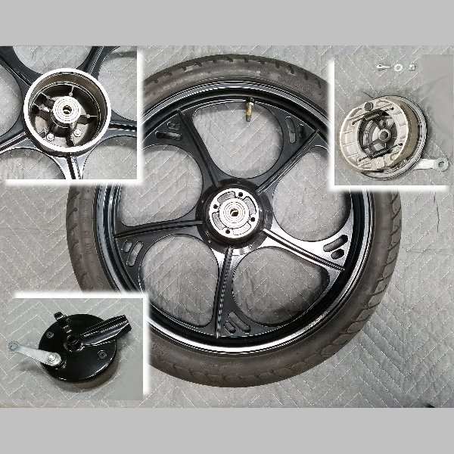

After calling up Kirk Swaney, the CEO of ShiftEV, he gave us information that the wheels that he stocks are from a largely-defunct moped company called Tomos Mopeds, who make 150 lbs mopeds with up to 300 lbs of carrying capacity-- perfect for our uses.